

Content’s

Our Alumni 1

Director's Message 2

About IIT PATH 4

Our Pedagogy 8

Foundation Builder 10

Engineering 12

Medical 15

Olympiad preparation” t p 17

Digital IIT PATH 27



Director's Message

Dear Parents and Students,

“*IIT PATH”* has worked with a mission to provide the best possible support and mentorship to students to help them crack the toughest Engineering/ Medical entrance exams in the world. We consider ourselves blessed to have guided thousands of students to IITs, AIIMS and other top Engineering & Medical Colleges year after year.

We have been able to convert so many students into national assets because of our child centric approach and feedback driven mechanism. Our faculty team consists mostly of Doctorates and Doctors who are passionate about teaching and dedicated to building the future of their students. The success of IIT PATH is based on the success of our students. We infuse in them the attitude that does not let them settle before mounting the heights of success and deriving the best not only academically but also socially.

Our most important philosophy is “Money will never be a barrier between a meritorious student and quality education at IIT PATH we feel very passionate about providing an academic platform to deserving and meritorious students from the weaker and under privileged sections of our society and giving them a fair opportunity to study with the best.

I thank you for showing interest in IIT PATH. I am sure your child will be able to achieve his/her dream of becoming a successful Engineer or a Doctor with IIT PATH.

Best wishes to your ward.



02

## “Reality is a manifestation of dreams”

“There is bound less joy when dreams of being an Engineer or Doctor turn into reality through IIT PATH”

#### - Praveen Tyagi (B.Tech. IIT-Delhi)

**About IIT PATH**

IIT PATH was established in 2010 by Dr. Azajul Haque Since inception, we believe in providing the highest quality of education while coaching our students for competitive exams. We are committed to make the process of learning fundamentally strong and enjoyable for the aspirants by using innovative teaching methods and having passionate and dedicated team of Doctorates & Doctors to give them thorough conceptual clarity. This strategy is the sole reason behind us being able to produce extraordinary results every year in our 4 definite integrals - Engineering, Medical, Foundation Builder and Education Abroad. We have consistently produced top results in competitive exams like JEE, NEET and Olympiads. We have a presence across India and have one of the largest pools of experienced faculties.



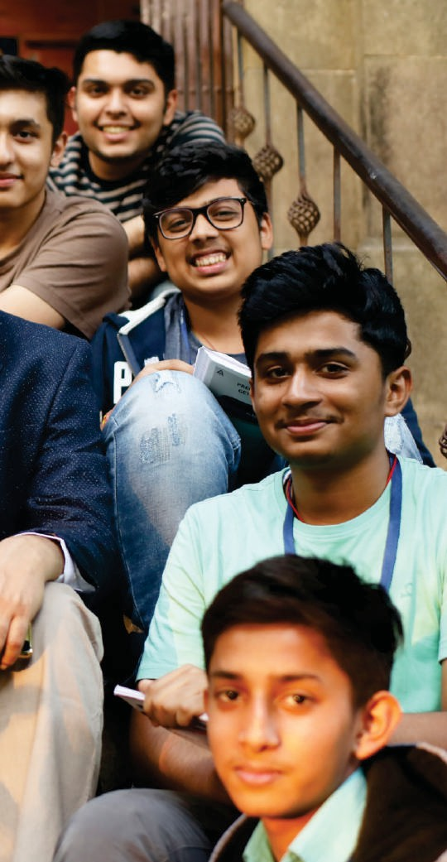

Our nation needs to harness the intellectual potential of our younger

generation to turn India into a superpower. Our vision is to impart

best quality education to students from seventh standard onwards for the top national

and global examinations and help them to fulfil their dream of enterin top Engineering and Medical colleges, through tech enabled learning and testing

solutions.

Redefining quality learning through innovation and farsightedness has

been a hallmark of IIT PATH DNA.

Our mission is to create an environment of academic excellence, utilizing modern technologies and pedagogical approaches to provide quality education.

SION

Everything we do at IIT PATH revolves around the well-being & all-round development of the

students. We, therefore, adopt a holistic learning approach that enables the

students to not just prepare for the exams at hand but also understand and apply theories & concepts across all the spheres of life.

Our academic and non-academic staff takes a keen interest in students' growth and

encourage them to do their best.

SION

## y IIT PATH?

09

Our Pedagogy

Child - Centric approach and Feedback Driven Mechanism

IIT PATH is a pioneer in revolutionizingthe concept of inclusive and extensive coaching in IIT JEE, NEET and Olympiad preparation in Mumbai, Delhi & other cities across India which enables the students to enhance their performance in thesecompetitiveexams.This approach helps students to save time and multiply their efforts. We have been consistently producing top results, as our educational program is imparted in the most time efficient manner.

Extensive study material prepared by

experienced faculty members

Team of highly qualified teachers comprising of



10 IlTians, Doctors and Doctorates

Precise training for competitive exams as well as school exams

Topic-wise tests,

major tests, All India Test Series(AITS)

to assess & evaluate students' performance.

Effective batch size in class and regular availability of teachers

in library for doubt solving

A gamified learning app which makes learning Math and Science fun

Regular feedback system, parent-teacher meeting & detailed analysis report after every major test



Video lectures by top faculty of JEE/NEET to learn and revise the concepts. Topic-wise test, Major test, All India Test Series(AITS) available for additional practice alongwith detailed analysis of tests in one portal. Timetable, important notices, booklet solutions & all records are stored within the system to ensure 24x7 access to students.

" Digital IIT PATH [https://www.digitalIIT PATH.in/](http://www.digitalpace.in/)

11

### Strengthening the foundation of children to make them future ready!

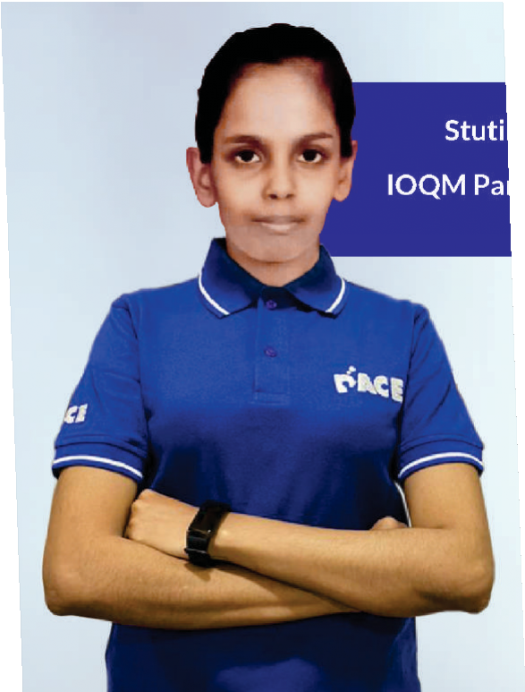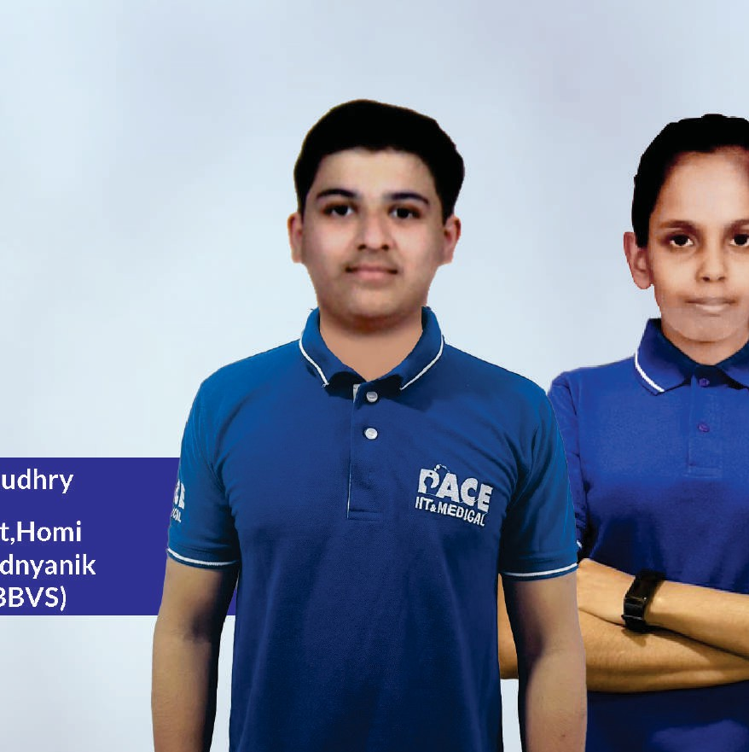

Maurya

-A Qualifer

Atharva Cha

Gold Medalis Bhabha Balvai Spardha (HB





Nurturing Young Minds

Std. VII to X

17

**Stay** ahead **of the competition by starting early**

**Handholding and nurturing children**

We at IIT PATH, are strongly motivated and dedicated to develop the inquisitiveness and curiosity in children into vision. Foundation Builder Program is the first step towards nurturing the young minds in our country. Moreover, learning at IIT PATH is a delightful experience due to exposure to experientiallearningand modernteachingmethodology.

**Strengthening the fundamentals of** Math & Science

The basic foundation of proficiency in Science and Math lies on the clarity of concepts which we diligently attempt to develop in them with clear understanding. Students get an opportunity to learn these subjects from highly qualified and experienced faculty, who make these subjects more interesting and easy to comprehend. We help our students think out-of- the-box, a skill set which is indispensable to succeed in competitive exams in future.



**Importance of competitive exams**

Preparing for competitive exams helps to identify scholastic talent in students. Aptitude and scientific orientation needs learning and practice to reach its full potential. Preparing for competitive exam is about giving a child he platformandexposure, helpingthemtodotheir best.

The focus of competitive exams is to impart factual knowledge and develop he required intellectual skills to apply that knowledge. The curriculum of hese exams aims to concretize what has already been learnt and take students to the next level. These develop the ability for independent work and objective thinking in students.

18

Benefits of IIT PATH Foundation Builder

Prepares the child for various competitive exams

Ahead of time preparation increases level of understanding



Out of box & beyon school books thinking skills

Makes the child future ready

Hones the

academic skills

Places the child at par with highly competitive peer group

19

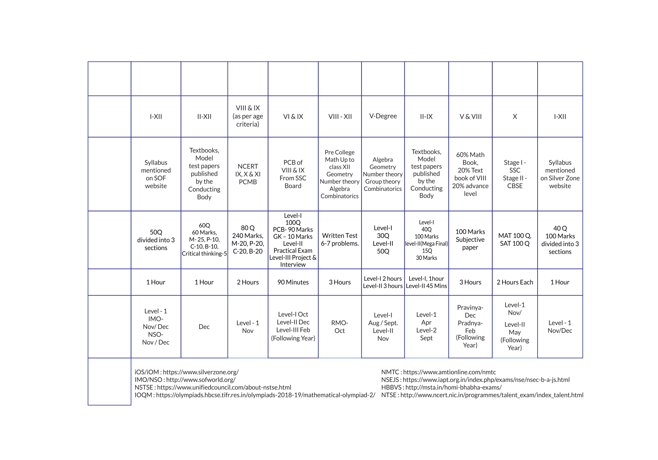

|  |  |  |  |
| --- | --- | --- | --- |
| Courses for students in standard yth7 8th/ gthZzoth | | | |
|  | Std / Grade Batch & Course **Description**  **Duration** | | |
| Std 7 | Batch - I Apr’24 - Nov’24  Batch - II June'24 - Jan’25 | This course aims to provide students with an early and comprehensive understanding of concepts in Mathematics and Science and enables them to gain an advantage in both school and competitive exams.  Lecture Duration: Sat (3hrs) & Sun(5hrs)  Students can be called for extra lectures if required |
| Std 8 | Batch - I Apr'24 - Nov'24  Batch - II June'24 - Jan'25 | This course is designed to build a strong foundation in Mathematics & Science and is designed to inculcate out-of-the-box thinking skills in students.  Lecture **Duration:** Sat (3hrs) & Sun(5hrs)  Students can be called for extra lectures if required |
| Std 9 | Batch - I Apr’24 - Nov'24  Batch - II June'24 - Jan'25 | This course fosters confidence and broadens up the logical and creative bent of mind, making it a problem-solving delight for the students. Preparatory sessions for Olympiad Exams in Mathematics and Science are also conducted on weekdays, after school hours, as per competitive exam schedule.  **Lecture Duration:** Sat (3hrs) & Sun(5hrs)  Students can be called for extra lectures if required |
| Std 10 | Batch - I Apr’24 - Nov’24  Batch - II June’24 - Jan’25 | This course helps students to be a problem solver, and to be ahead in preparation for their school, IIT-JEE & NEET competitive exams. NTSE and Olympiad lectures are scheduled on weekdays, after school hours, as per the competitive exam schedule.  Lecture Duration: Sat (3hrs) & Sun(5hrs)  Students can be called for extra lectures if required |
| Moving to Std 10 | 3 Years Course Apr’24-May’27 | This course is designed for ambitious students targeting top IIT-JEE/NEET ranks, we offer a synchronized learning program to ignite early success with comprehensive guidance, personalized mentoring, and strategic preparation. Lecture **Duration:** Sunday(6hrs)  Lectures in class 11“ will be continued in regular sessions. |
| Course Commencement   * Batch 1: Saturday, 6“April 2024 * Batch 2 : Saturday, 8“June 2024   24 * 3 years batch commencement: Sunday, 14“April 2024 | | | |

|  |  |  |  |  |
| --- | --- | --- | --- | --- |
| Fee Structure | | | | |
| Fee (T) GST Total Fee 2 lnstallments  (#) within 3 Honths  (#) | | | |  |
| 80,000/- | 14,400/- | 94,400/- | 49,560/- |
| 90,000/- | 16,200/- | 1,06,200/- | 55,4ó0/- |
| 1,00,000/- | 18,000/- | 1,18,000/- | 61,360/- |
| 1,20,000/- | 21,600/- | 1,41,600/- | 73,160/- |
| 6,50,000/- | 1,17,000/- | 7,67,000/- | 3,85,8ó0/- |
| Note: 1) No Fee should be paid in cash. IIT PATH will not be responsible for any admission done through cash payment   1. The amount of scholarship given to a student will be adjusted only in the second instalment. First instalment will be collected without the discounted amount. 2. Instalment charges will be levied in cases where instalment facility is provided. 3. There will be no instalment facility extended to a student who has received scholarship 50% or above. There will be a one time payment to be made in such cases. 4. Online payment details are available on : [http://iitiansIIT PATH.com/payment-page/](http://iitianspace.com/payment-page/) 5. Fee to be paid in favour of: “IIT-ian's IIT PATH Education Pvt. Ltd.” 6. GST rate will be applicable as per latest Finance Bill. Tax rate may change without any prior intimation. 25 7. No application for refund will be considered after 45 days of batch commencement. | | | | |

# IIT is a dream come true at IIT PATH!

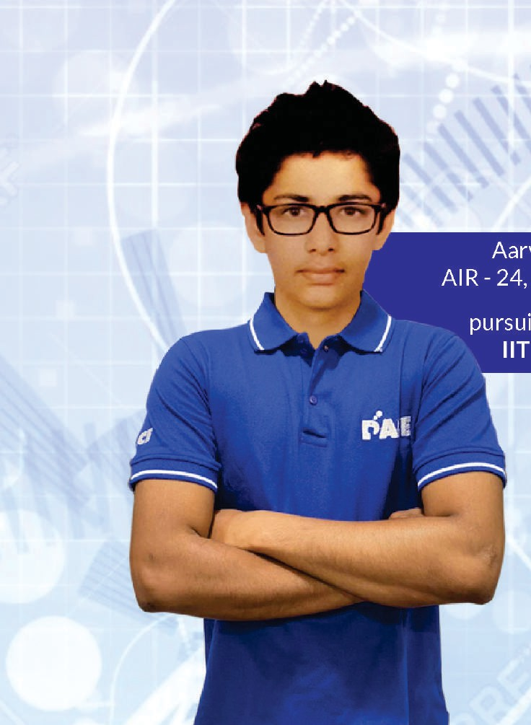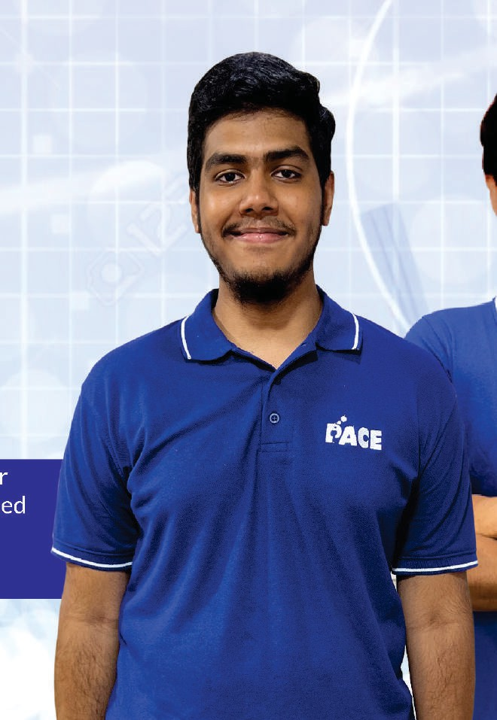

#### yan Dangi

JEE Advanced

ng B.Tech at Bombay

Ekansh Ravishanka AIR - 49, JEE Advanc

#### pursuing B.Tech at llT Bombay















Gear up for your future

Engineering



It's about using Mathematics & Science to solve real-time problems. By applying scientific and mathematical knowledge, engineers work to design, build, maintain and improve all sorts of things, including structures, machines,eIectronicdevices,systemsand processes.

Scope of Engineering

A degree in engineering can open many professional avenues and guarantees the beginning of astellar career. Engineering is avery broadfield that offersdozensofspecializationopportunities.

IITs/ NlTs

IITs/ NlTs are the most elite and finest institutions for engineering in our country, reputed for their quality of engineering education, world- class infrastructure&topcIassfacuIty.

IITs / NlTs are premier institutes of India conferred with the status of institutions of national importance.

IITs / NlTs are renowned worldwide for their quality of teaching and internationally acclaimed research, excellent infrastructure and for producing the best brains in the country.

During placement season, the best companies flank the IIT campuses, offering handsome packages and top-notch positions.

IITs/ NlTs open the portals to a plethora of options for higher studies and themostcovetedjobs.

28

Get the IIT PATH edge

Highly competitive peer group



Extensive and well-researched study materials

Faculty pool of IlTians and Academicians

IIT PATH has been consistently producing toppers of JEE in Maharashtra

JEE

E

One on one doubt sessions with regular tests and assessments

Strong selection track record

29

# All about JEE

JEE Main is conducted twice a year. Schedule of exam does not clash with Board Exams. NTA also conducts B.Arch & B.Planning exams scheduled along with JEE Main twice a year.

##### Scheme & Mode of Examination

JEE (Main) will be conducted in the following modes:

1. Paper 1(B.E./B. Tech.) in “Computer Based Test (CBT)” mode only.
2. Paper 2A(B. Arch): Mathematics (Part-I) and Aptitude Test (Part-II) in“Computer Based Test(CBT)“ mode only and Drawing Test(Part-III) in pen & paper (offline) mode, to be attempted on drawing sheet ofA4 size.
3. Paper 2B (B. Planning): Mathematics (Part-I), Aptitude Test (Part-II) and Planning Based Questions (Part-III) in Computer Based Test (CBT) mode

only.

**JEE Advanced**

* + This isthe second stage of entrance test for admissions to IITs, II5c, IIST, II5ERs forstudentswhoqualify in JEE Main.
  + Onlytop2,50,000successful candidates of JEE Main areeligible towritethisexam.
  + Conducted by the seven zonal IITs —IIT Bombay, IIT Delhi, IlTGuwahati, IIT Kanpur, IIT Kharagpur, IIT Madras and IIT Roorkee.
  + Twoobjectiveonline papers,eachofthree hoursdurationwithequalweightagegiventoPhysics,Chemistryand Mathematics.
  + The JEE Advancedexam is heIdeveryyeartentativeIyinthe3"weekof May.
  + For more details [kindlyvisithttp://jeeadv.ac.in](http://jeeadv.ac.in/)

JEE Main

Students in top 2,50,000

ranking of JEE Main will qualify JEE Advanced to give JEE Advanced

|  |  |
| --- | --- |
| Duration: 3 hours | Duration: 6 hours |
| Mode: Online | Mode: Online |
| Paper Type: Objective type + Numerical Questions (PCM) | Paper Type: Two Objective Paper (PCM) 3 hrs each |
| JEE Main is conducted twice a year.  For more details kindly visit https://jeemain.nta.nic.in | JEE Advanced is conducted once a year.  For more details kindly visit [http://jeeadv.ac.in](http://jeeadv.ac.in/) |

Admission to IITs, NlTs, IIITs and GFTIs will be on participation through Joint Seat Allocation Authority (JoSAA) on the basis of All India Rank(AIR) in JEE Advanced (for IITs), JEE Main (for NlTs, IIITs and GFTIs), subject to the condition that the candidate should have secured at least 75% marks in the 12“class examination, or be in the top 20 percentile in the 12t’ class examination conducted by the respective Boards. For more details kindly visitjosaa.nic.in

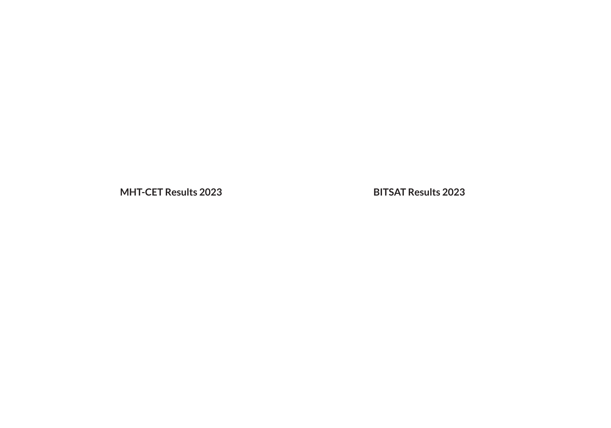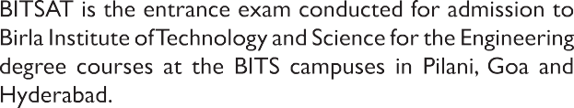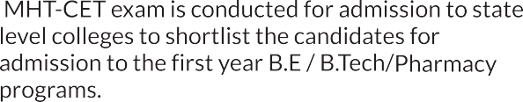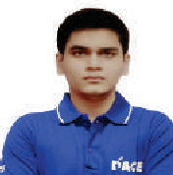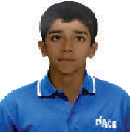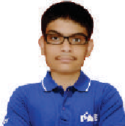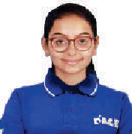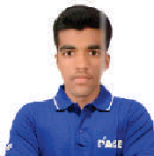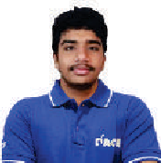

Courses

For Class XI, XII



**Course**

**Program**

**Course Description**

**JEE Advanced**

+ JEE Main

JEE Main

+ CET

**Distance Learning**

**Program**

Moving to

Std 10

Zenith Program

*SY^chronized Learning* Program

Two Year Program

Support Program

*After School Program*

Premier Program

*+Y^¢hronized* 1earning *Program*

JEE Advanced / JEE Main

ndia Test Series

(Online)

3 Years Course

Master the JEE Advanced syllabus along with board syllabus and excel in JEE through in-depth Physics, Chemistry, and Mathematics learning, taught by accomplished IlTians and academicexperts.

Lecture Duration: 18 hours per week.

This comprehensive course is designed to cover the syl abus of JEE Advanced in-depth, taught by accomplished IlTians and academic experts after school hours for effective learning.

**Lecture Duration:** 9hours per week.

This comprehensive course covers JEE Main, CET competitive exam syllabi, taught by accomplished IlTians and academic experts.

Lecture Duration: 18 hours per week.

This program is tai ored for students who are unab e to attend offline classes. Comprehensive study material will be provided to the students, alongside specialized onlineTopic-wisetestsandAllIndia Test Series for additional practice.

JEE Advanced - 15 On ine Practice Test(Oct- May) JEEMain - 15 Online PracticeTest(Oct-Apr)

This course is designed for ambitious students targeting top IIT-JEE ranks, we offer a synchronized learning program to ignite early success with comprehensive guidance, personalized mentoring, and strategic preparation.

Lecture Duration: Sunday(6hrs)

Lectures in class 11“wiII be continued in regularsessions.



**For Class XII passed students**

**JEE Advanced**

+ JEE Main

Repeaters

(@ Andheri/Thane/NeruI/Dadar)

This program is designed for students aiming to excel in JEE reattempt. Students will

strategies. Study material, alongside specialized Topic-wise Tests(TWTs) and All India

be offered comprehensive guidance with our targeted approach and proven teaching

Crash Course

This course is designed to revise the entire syllabus JEE in a short period and help

Test Series, will be provided tostudents Lecture Schedule: 3-4daysaweek, 6hrs aday

students cover important topics alongwith their weak areas systematically.

NOTE: 50% concession to all IIT PATH students for repeaters program

|  |  |  |  |  |  |
| --- | --- | --- | --- | --- | --- |
| Fee Structure | | | | | |
| Batch commencing Fee({) GST Total Fee **2 Installments**  **within 3 I"1onths** | | | | |  |
|  | | | | |
| 7“, 16“ & 25“ - April  7“ & 25“ - May | **6,00,000/** | 1,08,000/ | 7,08,000/ | 3,56,360/- |
| 7“&25”-June |  |  |  |  |
|  |  |  |  |
| 7“ & 25“ - July  7“ - August | 3,00,000/- | 54,000/- | 3,54,000/- | 1,79,360/- |
| 7th16“ & 25“ - April  7“ & 25“ - May  7“&25“-June  7“ & 25“ - July  7“ - August | 3,00,000/- | 54,000/- | 3,54,000/- | 1,79,360/- |
|  |  |  | 20,000/- |  |
|  |  |  | 5,000/- |  |
| 14 Apr’24 -May'27 | 6,50,000/- | 1,17,000/- | 7,67,000/- | 3,85,860/- |
|  | | | | | |
| 25“ June & 7“ July 2024 | 1,50,000/ | 27,000/ | 1,77,000/- | 90,860/ |  |
| Nov 2023 - June 2024 | 30,000/- | 5,400/- | 35,400/- |  |
| Note: 1) No Fee should be paid in cash. IIT PATH will not be responsible for any admission done through cash payment   1. The amount of scholarship given to a student will be adjusted only in the second instalment. First instalment will be collected without the discounted amount. 2. Instalment charges will be levied in cases where instalment facility is provided. 3. There will be no instalment facility extended to a student who has received scholarship 50% or above. There will be a one time payment to be made in such cases. 4. Online payment details are available on :http:/iitiansIIT PATH.com/payment-page/ 5. Fee to be paid in favour of: “IIT-ian's IIT PATH Education Pvt. Ltd.” 6. GST rate will be applicable as per latest Finance Bill. Tax rate may change without any prior intimation. 7. No application for refund will be considered after 45 days of batch commencement. | | | | | 35 |

# Unlock your path to the top medical colleges with IIT PATH!

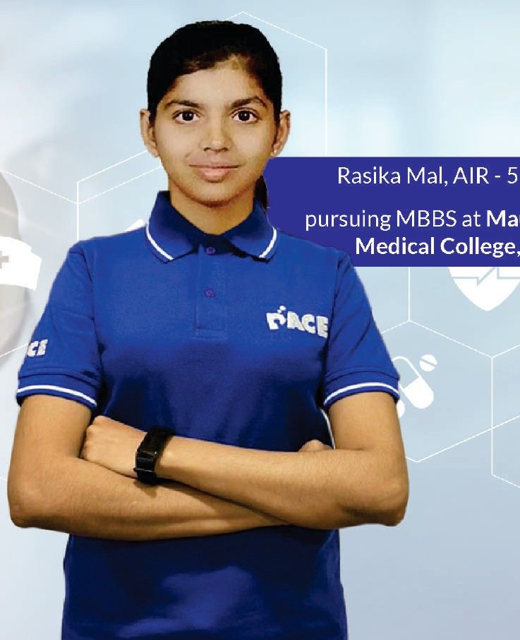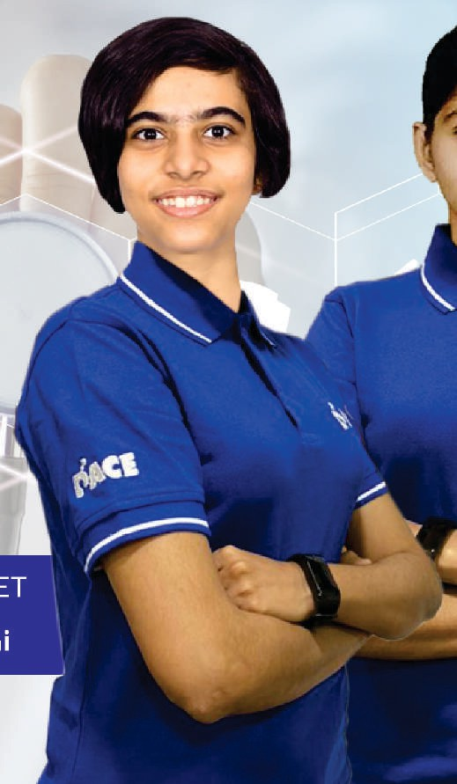

#### 5, NEET

ulana Azad

Delhi

#### Anushka Kulkarni, AIR -24, NEE pursuing MBBS at AIIMS Delh





**Pursue your dream as a Doctor**

Your zeal toserve people, critical thinking and working diligently under pressure can present a plethora of careeroptions for you. If the aforementioned qualities are merged with compassion then medicine is definitely an ideal career path for you. Medicine is a career that offersopportunitiesto improve people's health and save lives. So,ifyouthinkyou have that zeal toserve peopIe,thenchooseMedicine as acareer.

#### NEET preparation at IIT PATH



Incorporates easy to use tips and tricks

Regular tests and

assessments

Extensive and well-researched study material

Highly competitive peer group

Qualified faculty

Competitive atmosphere with personalized attention

One on one doubt sessions

All about NEET

Central Government has established the National Testing Agency to conduct entrance examination for admission/fellowship to higher educational institutions.

The responsi ty of NTA is limited to the conduct of the entrance test NEET- (UG), declaration of result and providing All India Rank to the Directorate General of Health Services, stry of Health and FamiIyWeIfare,GovernmentofIndia for counselling of 15%AII India Quota Seats and all seats of Deemed Universities/Central Universities/ ESIC & AFMC including Delhi University (DU), BHU & AMU and providing the result to the StateCounselling Authorities and admitting Institutions.

Admissiontoallseats of MBBS/BDSwiII be done through NEET(UG). Following are the seats available under different quotas:

* All IndiaQuota Seats
* State Government Quota Seats
* Central Institutions/Universities/DeemedUniversities
* Central PoolQuota Seats
* State/Management/NRlQuota seats in Private Medical/DentalCollegesoranyPrivate University

##### Entrance test date

t

National E tyCum EntranceTest NEET(UG) isusuallyconductedin 1 Thedurationofthetest will be3 hours(NEETisconducted offline).

eek of May.

Pattern of NEET

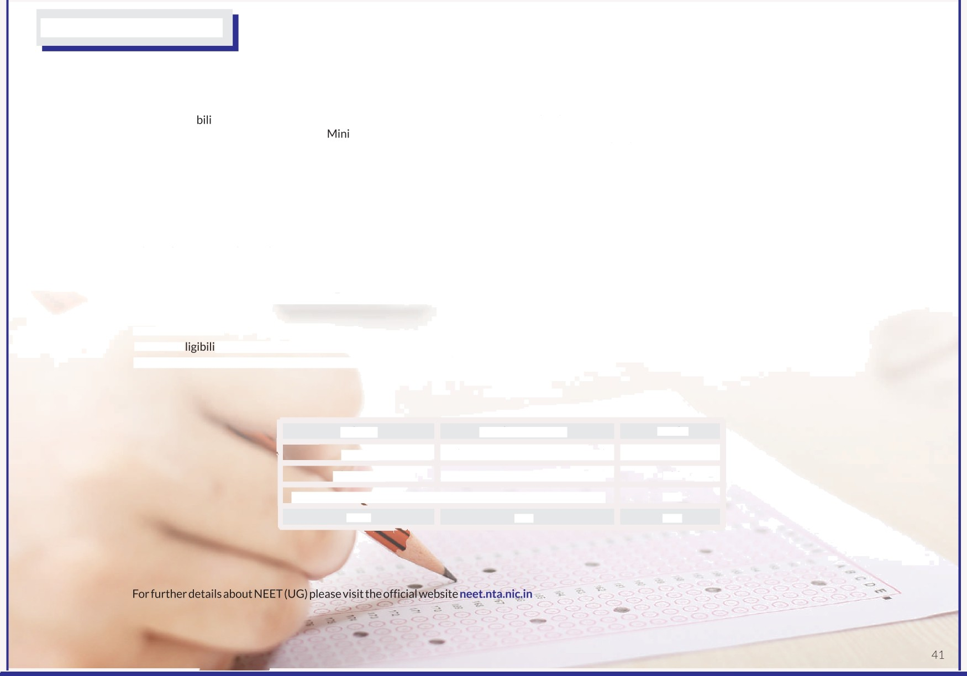

|  |  |  |
| --- | --- | --- |
| Subject | Number of MCQs | Marks |
| Physics | 45 (Section A - 35, Section B - 15) | 180 |
| **Chemistry** | 45 (Section A - 35, Section B - 15) | 180 |
| Biology(Bota & Zoology) | 90 (Section A - 35, Section B - 15) | 360 |
| Total | 180 | 720 |



For Class XI and XII

Courses

|  |  |  |  |
| --- | --- | --- | --- |
| Course | Program | | **Advantages** |
| NEET +  **Olympiads** | Two Year Program | **Zenith Program**  *Synchronized Learning Program* | Master the NEET syllabus along with board syllabus and excel in NEET through in- depth Physics, Chemistry, and Biology learning, taught by highly qualified faculty (mostly PhDs/Doctors).  LectureDuration: 18 hours per week. |
| Support Program  After *S¢hool Program* | This comprehensive course is designed to cover in-depth syllabus of NEET, taught by highly qualified faculty (mostly PhDs/Doctors) after school hours for effective learning.  LectureDuration: 9 hours per week. |
| **NEET** | Distance Learning Program | | This program is tailored for students who are unable to attend offline classes. Comprehensive study material will be provided to the students, alongside specialized onlineTopic-wisetestsandAll India Test Series for additional practice. |
| **All India Test Series**  (Online/Offline) | | 15 offline NEET test(Oct-Jan)  15 online NEET test after boardexamtillNEETexam |



For Class XII passed students

|  |  |  |
| --- | --- | --- |
| **NEET** | Repeaters  (@ Andheri/NeruI/Dadar) | This program is designed for students aiming to excel in NEET reattempt. Students will be offered comprehensive guidance with our targeted approach and proven teaching strategies. Study material, alongside specialized Topic-wiseTests (TWTs) and All India Test Series, will be provided to students  Lecture Schedule: 3-4daysaweek, 6 hrs a day |
| Crash Course | This course is designed to revise the entire syllabus NEET in a short period and help students cover important topics alongwith their weak areas systematically. |

NOTE: 50% concession to all IIT PATH students for repeaters program

|  |  |  |  |  |  |  |  |  |
| --- | --- | --- | --- | --- | --- | --- | --- | --- |
| Fee Structure | | | | | | | | |
|  | Batch commencing |  |  | | GST | Total Fee | 2 Installments  within 3 Nonths |  |
|  | | | | | | | |
| 7“, 16“ & 25 April | | | 3,75,000/- | | 67,500/- | 4,42,500/- | 2,23,610/- |
| 7“ & 25“ - May | | |  | |  |  |  |
| 7“ & 25“ - June | | |  | |  |  |  |
|  | |  |  |  |
| 7“ & 25“ - July | | |  | |  |  |  |
| 7“ - August | | | 3,00,000/- | | 54,000/- | 3,54,000/- | 1,79,360/- |
| 7“, 16“ & 25t"- April  7“ & 25“ - May | | |  | |  | 20,000/- |  |
| 7“ & 25'" - June | | |  |
|  |
| 7“ & 25'" - July | | |
| 7“ - August | | |
|  | | | | | | | | |
| 25“ June & 7“ July 2024 | | | 1,50,000/- | | 27,000/- | 1,77,000/- | 90,860/- |  |
|  | 16“ Oct to May 2024 (course will resume  next day after XII“ Boards) |  | 30,0 | 00/- | 5,400/- | 35,400/- |  |
|  | Note: 1) No Fee should be paid in cash. IIT PATH will not be responsible for any admission done through cash payment   1. The amount of scholarship given to a student will be adjusted only in the second instalment. First instalment will be collected without the discounted amount. 2. Instalment charges will be levied in cases where instalment facility is provided. 3. There will be no instalment facility extended to a student who has received scholarship 50% or above. There will be a one time payment to be made in such cases. 4. Online payment details are available on :http:/iitiansIIT PATH.com/payment-page/ 5. Fee to be paid in favour of: “IIT-ian's IIT PATH Education Pvt. Ltd.” 6. GST rate will be applicable as per latest Finance Bill. Tax rate may change without any prior intimation. 7. No application for refund will be considered after 45 days of batch commencement. | | | | | | | 45 |

# Olympiad Preparation at IIT PATH

Olympiads are internationally recognized competitions in various fields of knowledge. They are the highest level of examinations and are hosted by different countries every year. Participation in any of the olympiads is worldwide recognised and is considered as a great achievement. International olympiads are held every year in Mathematics, Physics,Chemistry, Biology, Astronomy and Junior Science.

IIT PATH has attained an exalted prestige producing the best results at olympiads (Physics, Chemistry, Mathematics, Astronomy & Biology) year- after-year. IIT PATH students have won 12GoId medals,7SiIvermedaIsand 3 Bronze medals in InternationalOlympiads.

We provide specialized study material with assignments & tests. The fact that these olympiads are held internationally and, our students are successful in them consistently, is atestimony to our high standard of teaching &impeccablequalityofteachers.

After this analysis, we make a personalized study plan to focus on the weak areas and bring out the best of the students. If a non-IIT PATH meritorious student wishes tojoin IIT PATH to prepare for olympiads, he/she has togo through an entrance test along with a personal interview.

For the selection of this batch, we conduct an objective test and select the top 50 students across Mumbai. Separate batches for PCMB will be formed and students will be mentored by senior most faculty of IIT PATH.

Test date: Mid August 2023 **Mode:** Offline **Registration fee:** Rs. 1500 per subject **Olympiad batch commencement:** End of August 2023 (3 hrs., 1lecture per week)

**About International Olympiads**

The International Olympiad (IO) programme follows a five stage process.

All the subsequent stages are conducted by Homi Bhabha Centre for Science Education (HBCSE), Mumbai. ([www.hbcse.tifr.res.in)](http://www.hbcse.tifr.res.in/)

National Standard

Examinations (NSEs):

Indian National Olympiad

(INO) examinations:

Orientation-Cum-Selection Pre Departure Training

Camps (OCSC): " (PDT): These students

International Olympiad

(IO): Participation in

Physics, Chemistry, Biology, Astronomy organized by IAPI

The eligible students from stage one can participate in INO in respective subjects.

For these camps, about 35 students in each subject will be selected from INO on performance basis.

will have a Pre— Departure Training (PDT) for two weeks.

International Olympiad (IO) of the selected students.

(Note:- National Board for Higher Mathematics has been organizing Mathematical Olympiad since 1990. For details, visit [www.nbhm.dae.gov.i For more details, visit website: [www.iapt.org.in](http://www.iapt.org.in/) | E-mail: [iapt@vsnl.net](mailto:iapt@vsnl.net)](http://www.nbhm.dae.gov.i/)



53

Our Social Initiatives - Doing our bit for society

**Mr. Praveen Tyagi, who hails from a small village in Ghaziabad(UP), understands the "Importance of Education” & believes in the philosophy “Money will not bea barrier between a meritorious student &quality education at IIT PATH”.**

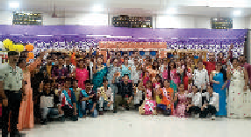

2021: Super "50" Batch (Mumbai)

24 out of 26 students have been admitted to prestigious Institutions like IITs/NlTs & 21 out of 24 students have got admitted to Top Medical colleges.

2019: Super "50" Batch (Mumbai)

The initiative of empowering the tribal students is taken up by the Tribal Development Department, Govt. of Maharashtra and IIT PATH Educational Trust. This scheme of Super 50 is proposed for the benefit and upliftment of the tribal community, which enables the tribal students to fulfil their dream of becoming eminent engineers and doctors. 50 meritorious students were selected on the basis of an examination from the lot of 16000 students. Super 50 batch of 2019 was launched in gracious presence of Hon. Dr. Ashok Uike, Minister of Tribal Development, Dr. Parinay Fuke, Minister of State for Public Works, Tribal Development and Forest, Govt. of Maharashtra, Mrs. Manisha Verma, Principal Secretary, Tribal Development Department, Shri Rajendra Gavit MP Palghar, Shri Paskal Dhanare MLA Dahanu. Harishchandr Bhoye, Tribal Aghadi BJP Maharahtra,SantoshJanatheSecretary BJP Palghar district, Mr. PraveenTyagi,Trustee,IIT PATH Educational Trust

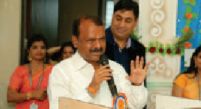

**2014: Training "Super 50 girls” batch in** collaboration with Women and Child Welfare Department of Maharashtra



IIT PATH had run a project under the women welfare policy in collaboration with Women and Child Welfare Department, Maharashtra Government for 2 years in which 50deservinggirlsget freetraining for the preparation of JEE Main, JEE Advanced and HSC.

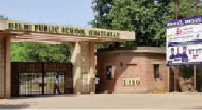

2013: Super "50" Batch (Ghaziabad and Delhi/ NCR)

The goal of Super "50" batch is to ensure a level play field for the meritorious yet underprivileged students of Ghaziabad/NCR by providing qualityeducationforschool/board curriculum and the most prestigious national & international-levelEngineering and Medical entrance exams.

2010: Training the SC children in collaboration with the Social welfare

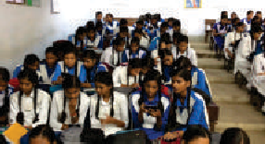

IIT PATH collaborated with the Social Welfare Department of the Maharashtra Government for a new social scheme. Based on it, we had offered free training & accommodation to the meritorious and underprivileged Scheduled Caste children for Boards, Engineering & Medical entrance exams.

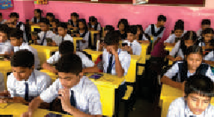

2009: Training the underprivileged meritorious students in collaboration with MCGM (Municipal Corporation of Greater Mumbai) Starting in 2009, IIT PATH got a chance to administer the MCGM till 2013. During these four years, we gave our best to guide and polish the BPL (Below Poverty Line) students inevery possible way to provide equal opportunity for deserving students and brighten their future.

**2009: Free education for the children of Mumbai Police Constables**

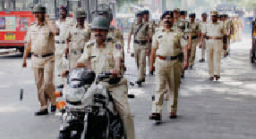

After Taj terror attack in 2008, Tyagi sir's heart went out for those Policemen & their family members who lost their lives & were badly injured. Tyagi sir then decided to provide free education to all the children of policeconstables in Maharashtra.

Helping the single parent in their child's education



IIT PATH actively supports the education of the meritorious children of single parent who are not able to afford their child's education. The institute provides scholarships and the best possible resources to the children of single parent.

58



Features of Digital IIT PATH

Prepare for competitive exams with top quality education at the comfort of your home

Live Interactive Lectures

 Doubt Solving

Study Material



ndia's Top Educators

VideoLecturesLibrary



Real-Time Reporting &Analysis

Guidance &Mentorship

Innovative +Gamified LearningwithSTEPapp

Regular + Rigorous Testing

To know more - digitaIIIT PATH.in | 18002665007/ 7700044482/ 7700044483

IIT‹MEDICAL



To know more - IIT PATHeschooI.com



59